Fly Dressers Guild
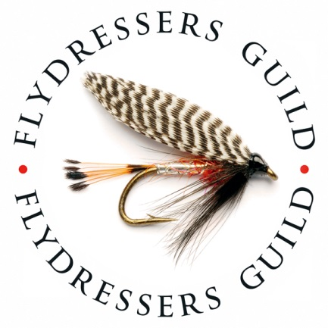

Elinor Trout Fishery 28th April 2019
Rules of the competition

Registration
All competitors must be current members of the Fly Dresser’s Guild
All competitors must register with the organiser by 8.30am on the morning of the competition.
The Competition
I've unfortunately had to raise the entry fee a little this year, the food in the Woolpack inn is a bit more expensive but going on our last visit there it is worth it. We always try to keep the entry fee to a minimum.
Fishing will be from 9.30am
Anglers may kill the first 4 fish and thereafter catch and release a further 8 fish
The winning angler will be the one with most fish. In the event of a tie, the weight of the first 4 fish will decide the outcome.
There will be prizes for 1st, 2nd and 3rd Individuals. Best team of 3 and largest fish
Any fish caught and released must be unhooked in the net and witnessed by another competitor. Anglers will; have a card to record their C&R catches. This should be initialled by the witnesses.
The Match will be fished on a “Roving” basis. Anglers are NOT to hog one spot and team members may not fish side by side.
Phones to be used in emergency only please.
No communication by mobile phone with team members will be allowed.
The after competition meal & awards will be at the Woolpack inn, Islip, NN14 3JU
The fishing rules
All anglers must be in possession of a current fishing licence.
Fishing will be by fly fishing only, with up to 4 flies allowed
No flies larger than a size 8 longshank to be used.
The use of the bung or other indicator is allowed as is “roly poly” retrieve
Once a limit of 4 fish has been killed the angler may catch and release a further 8 fish to a total of 12 fish
Anglers must keep their fish separate from those of other anglers.
Catch and release must be with barbless or crushed barb hooks only.
Catch and release No buoyant flies on sinking lines A washing line set up on a floating line is allowed.
All catch and release fish must be netted and unhooked in the water to count. Assistance is allowed.
Wading is permitted but not within 25 yards of another angler. Wade with consideration and in safety.
A maximum of two rods may be assembled and rigged at any time
All anglers must carry an approved landing net
Please remember this is an event aimed at bringing together the members of the Guild in friendly competition. Please be considerate towards your fellow members.
Anglers who complete their 12 fish limit must stop fishing.
All anglers must return to the lodge for weigh in by 5pm
Any questions, please contact fishing@flydressersguild.org

