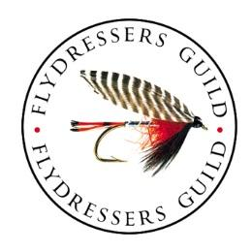
The Fly Dressers’ Guild

John Watts Trophy 2020 – Entry Form
To be held on Saturday 29th August 2020 at Draycote resovoir.
Cost of entry is £160 per team or £40.00 per angler
Note: | - ALL team members MUST be members of The Fly Dressers’ Guild.  - All entrants MUST abide by Government Covid 19 regulations.  - ALL team members MUST read a copy of the John Watts Competition Rules and the Draycote Catch & Release Rules before taking part in the competition  - Substitutes will be allowed on the day but must show their valid FDG membership card at registration  - Entry forms to be returned to Lee Hooper by 1st August 2020 with full payment (cheques to be made out to The Fly Dressers’ Guild).

Branch/ Team Name:
Name (BLOCK CAPITALS please) |  | FDG Membership No. | Prefer to fish from drifting boat?  (Yes/ No) | OAP on date of competition? (Yes/ No)
By submitting this form, the Team Captain confirms that he/ she has read the John Watts Competition Rules and the Draycote Catch & Release Rules and has made sure (or will make sure) that all team members do the same.

Please send completed entry forms and payment to the Fishing Competitions Secretary,
Lee Hooper. 10 Mill cottage, Mill Lane, Bishopstrow, Warminster, Wilts. BA12 9HJ

